EXPERIMENT 11 VMWARE

Step 1: Create a new virtual Machine

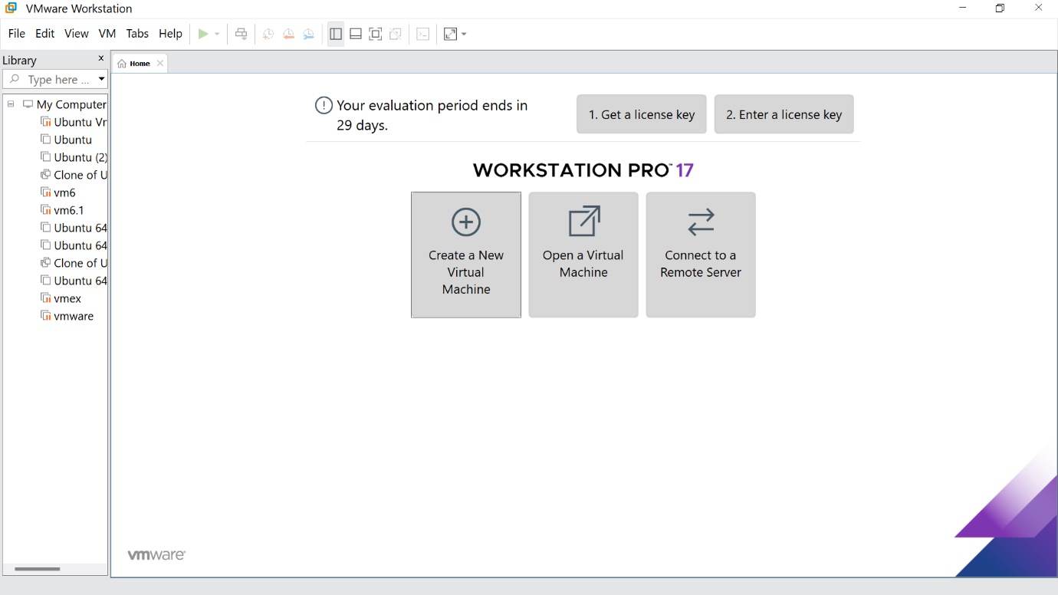

Step 2: Click the Typical option and click Next

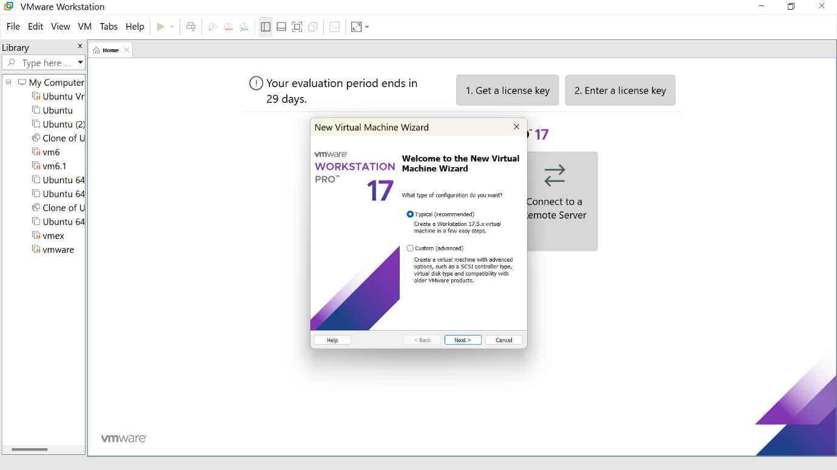

Step 3:Click the install option and proceed to next step

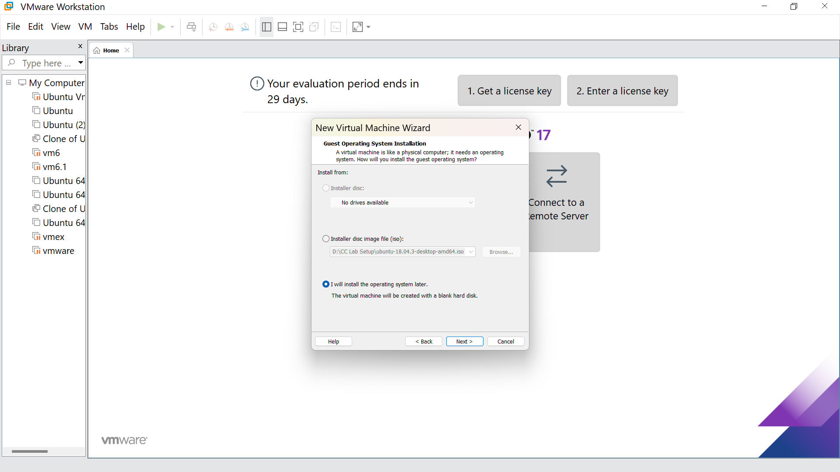

Step 4 :Select Linux option and click Next

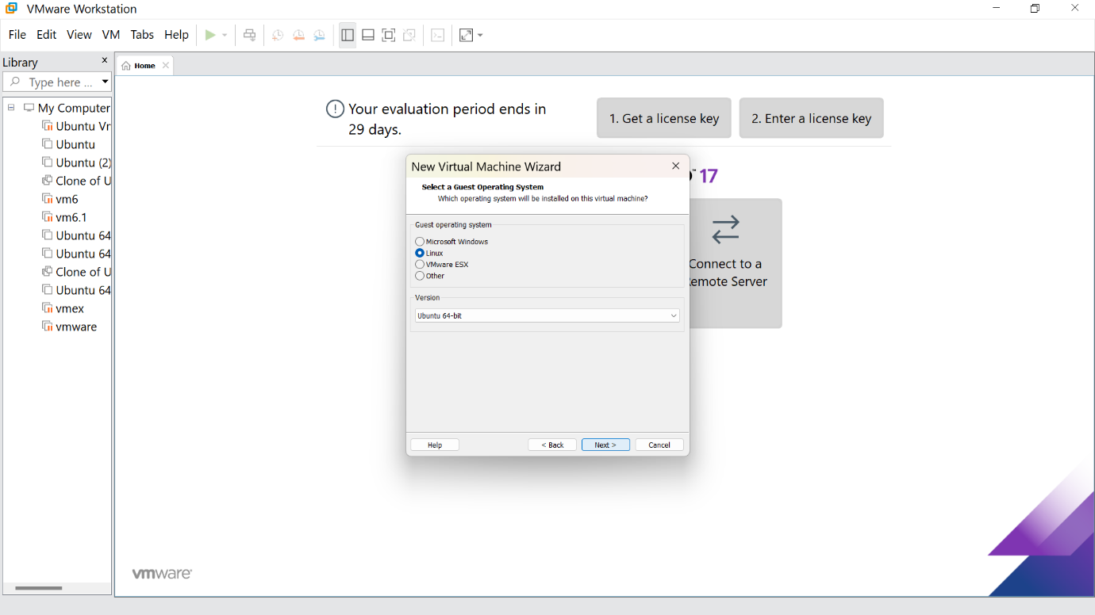

Step 5: Give the name for the virtual machine(optional) and click next

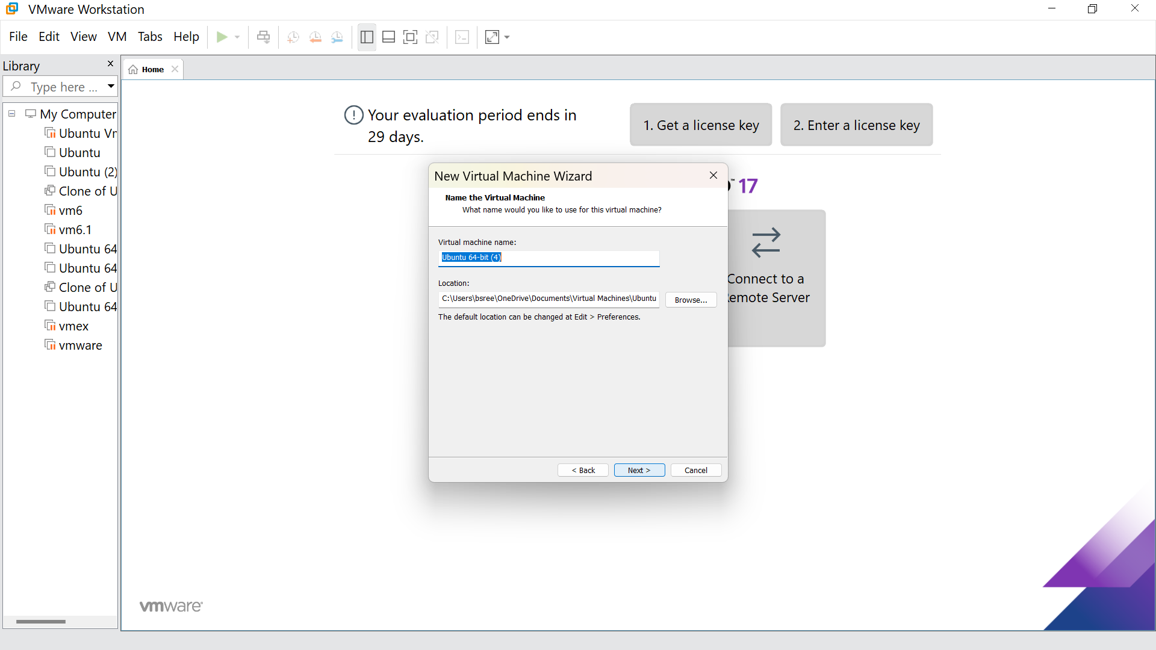

Step 6: Select the option to store the disk in single file and click next

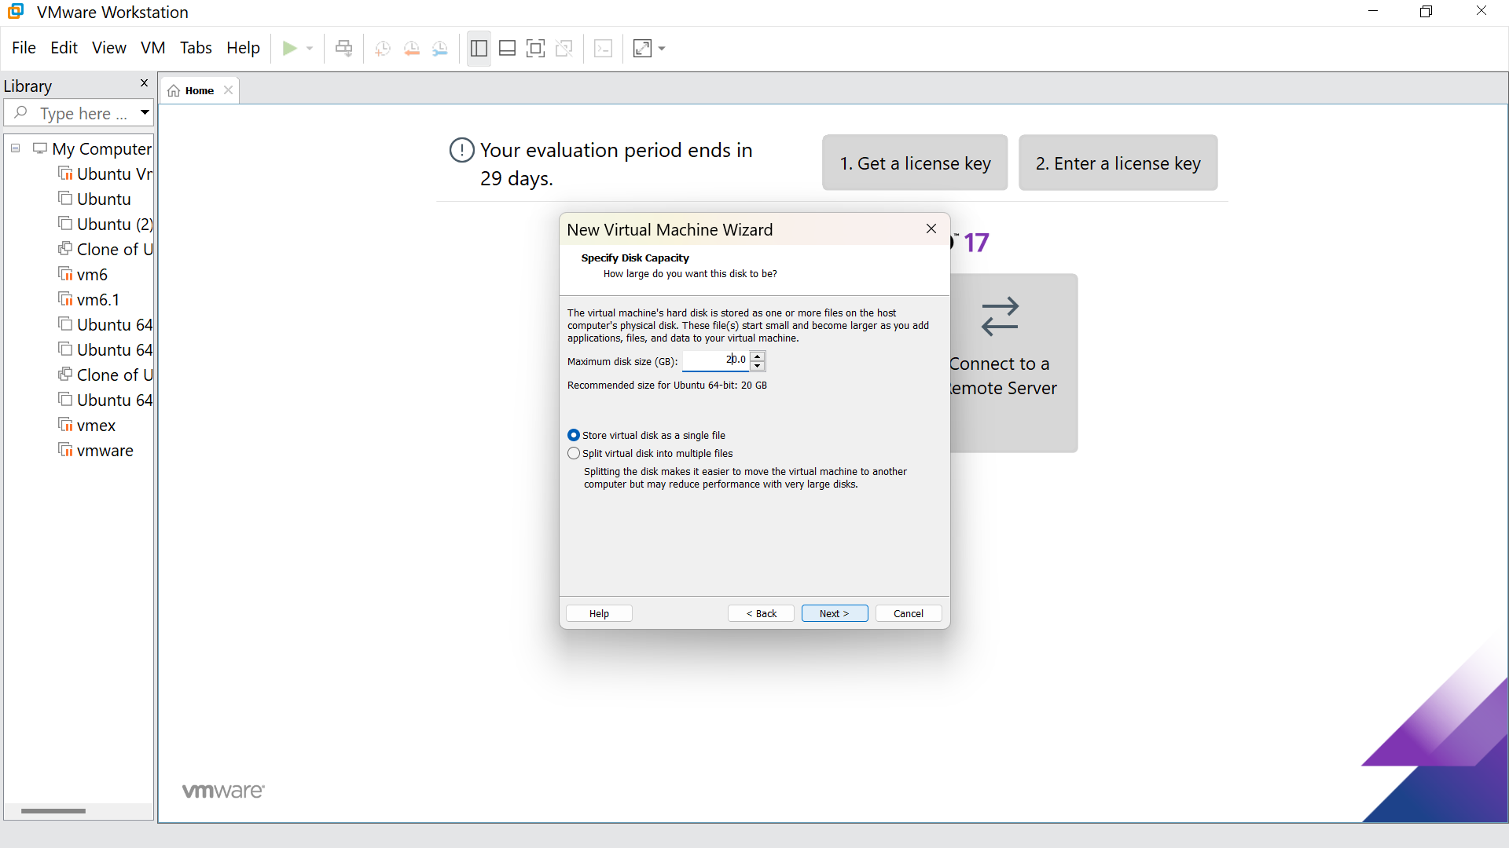

Step7:Our new VM is ready ,click finish

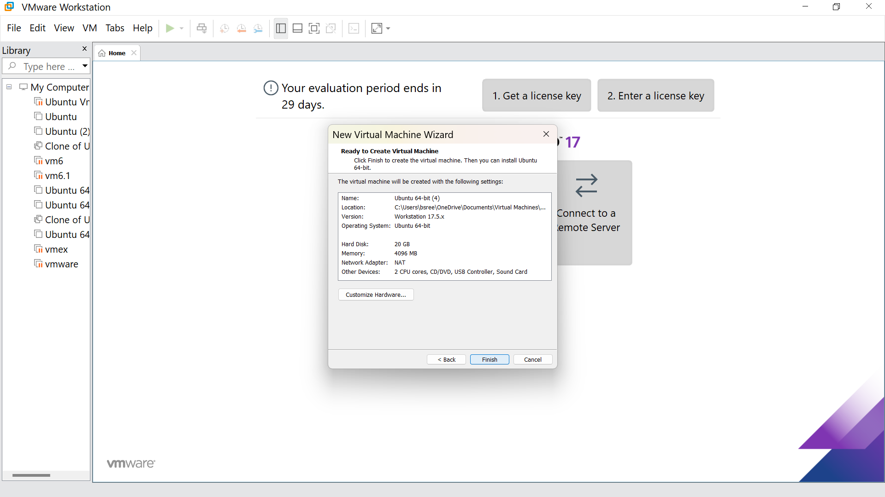

Step 8: This is the creation of VM

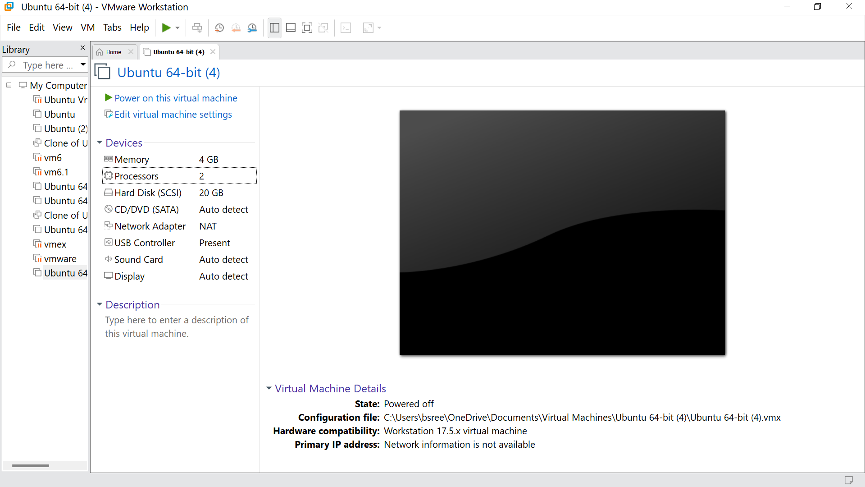

Step 9: Go to the processors and give the number of processors as per your requirement, click ok

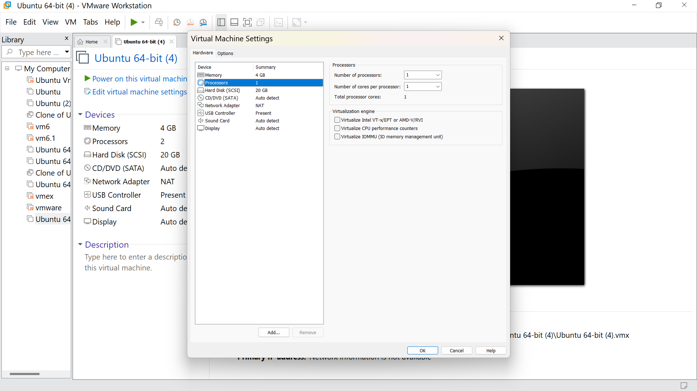

Step 10: Hence we got the output

